Research and gather a collection of ideas for possible art assets of game characters

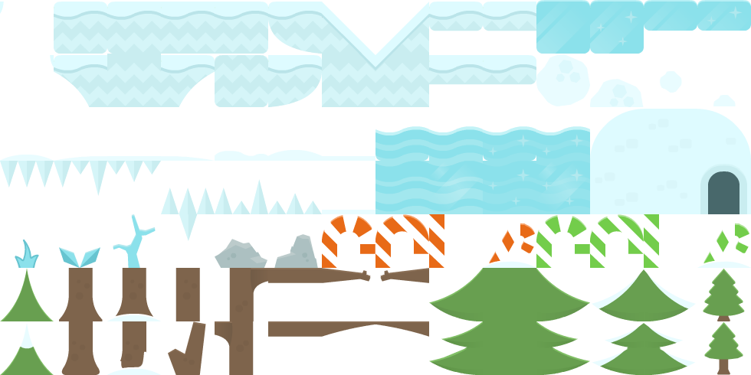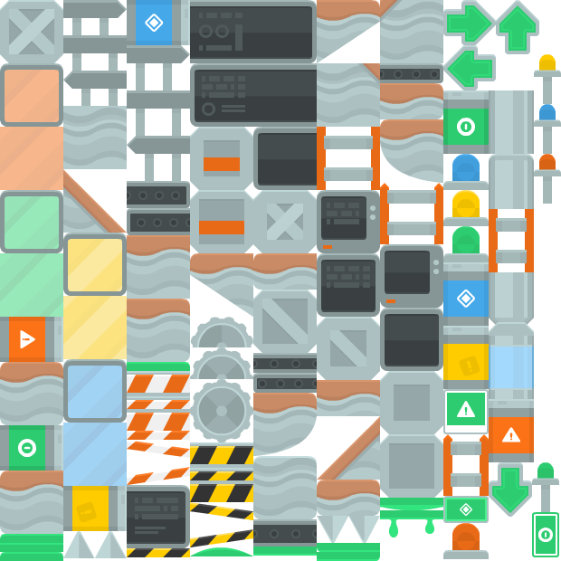Each of our levels could be based in a different biome or environment for one of our levels I could be based on these assets provided which could also be used on a factory level

2

1

For our first level we could have a Ice cave which is where we can use some ice assets to make the level feel realistic and can be used for the ice cube characters start of his journey.

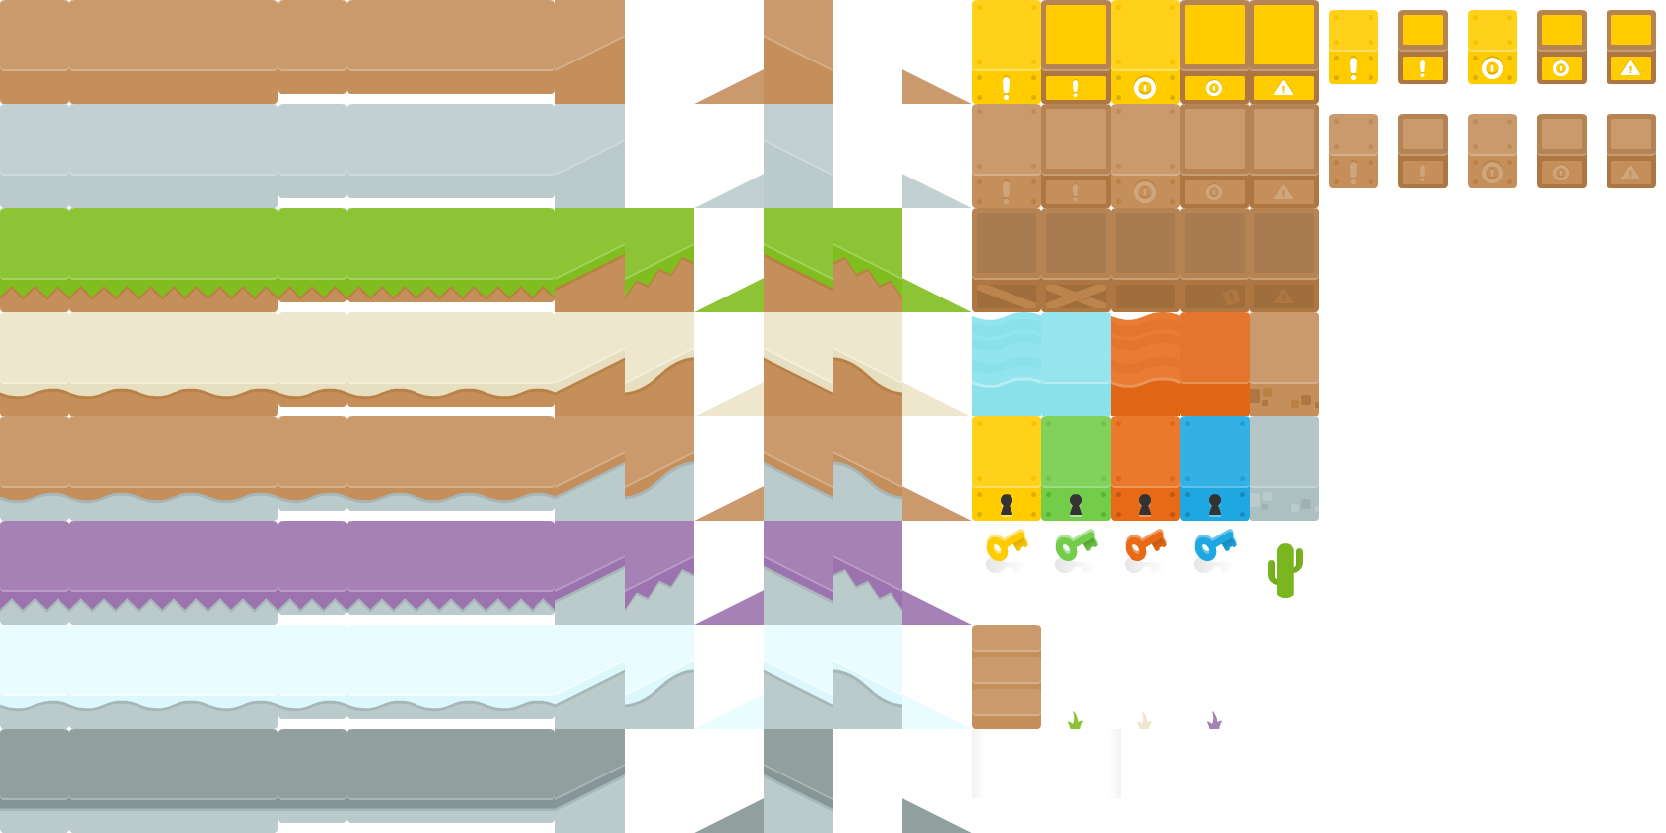

These assets can be used for many of the levels as they include different biome sprites that can be used such as water, fire, grass etc, it also include keys that can be used to unlock the next levels.

Key elements of brief

Solution

Recorded walk through of game

List of exact deliverables of what is going to be produced for week 12.